Aptech e-project

Lab automation

Project name: SRS Electrical appliances

Faculty:miss Kinza khan
Introduction:
The SRS Electrical appliances are the manufacturers of some electrical products like switch gears, fuses, capacitors, resistors, etc. These products after manufactured they are sent for testing where the product is subjected to some testing conditions, and then after the testing is successful at their laboratories, they are sent to CPRI for further testing process, so that they can get it approved from CPRI and then release the product into the market. If the testing fails then the product is sent back for re-manufacturing it and then they are again subjected to tests.

Requirements:
The details are needed to be captured based on the type of the testing and as well based on the product.

The status of the testing and as well the detailed remarks is also needed to be captured.
An advanced search option is needed to be included so that one can fetch the details of the testing at an ease.

Acknowledgements
E-Project Synopsis
E-Project Analysis
E-Project Design
DFD’s
Flowcharts
Process Diagrams
Database Design / Structure
Screen Shot’s
Source Code with Comments
User Guide
Developer’s Guide
Module Description
Database:

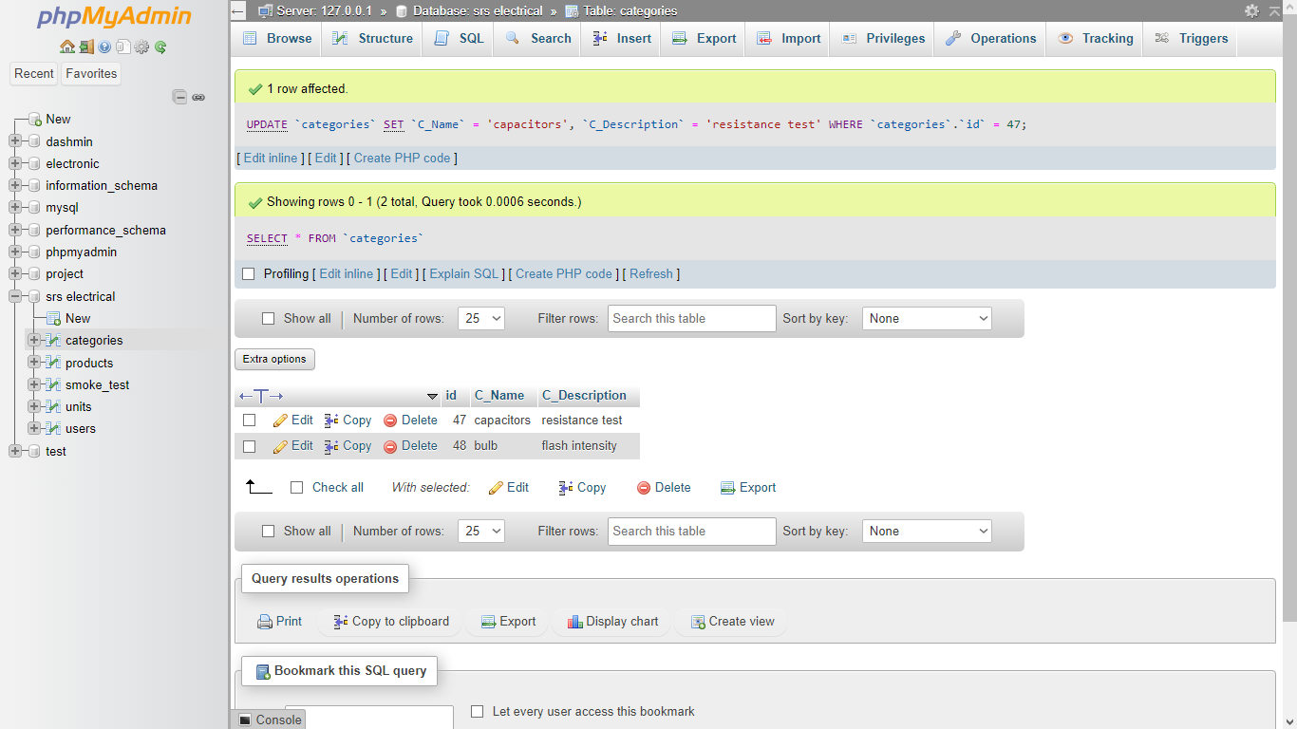

CATEGORIES

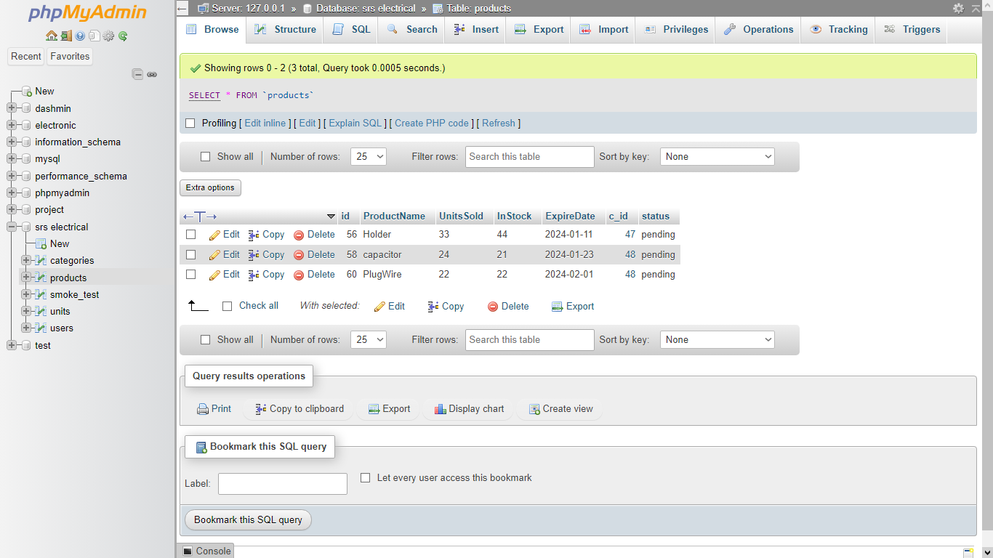

PRODUCTS

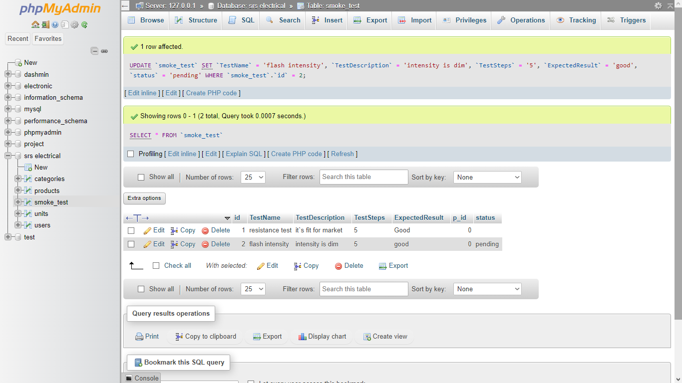

SMOKE TESTING

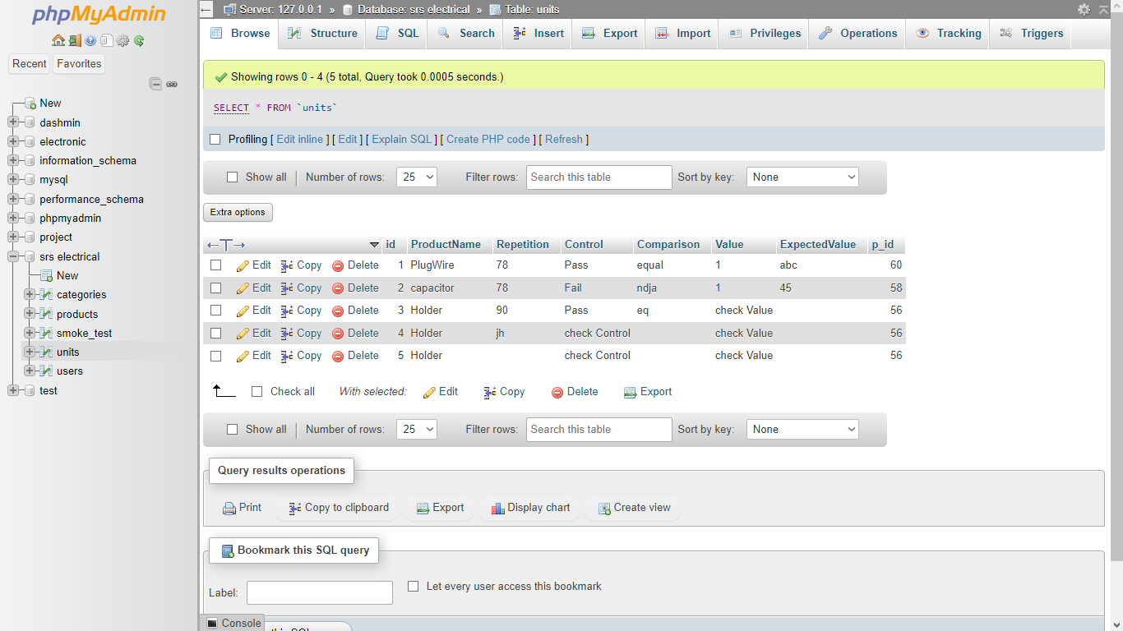

UNIT TESTING

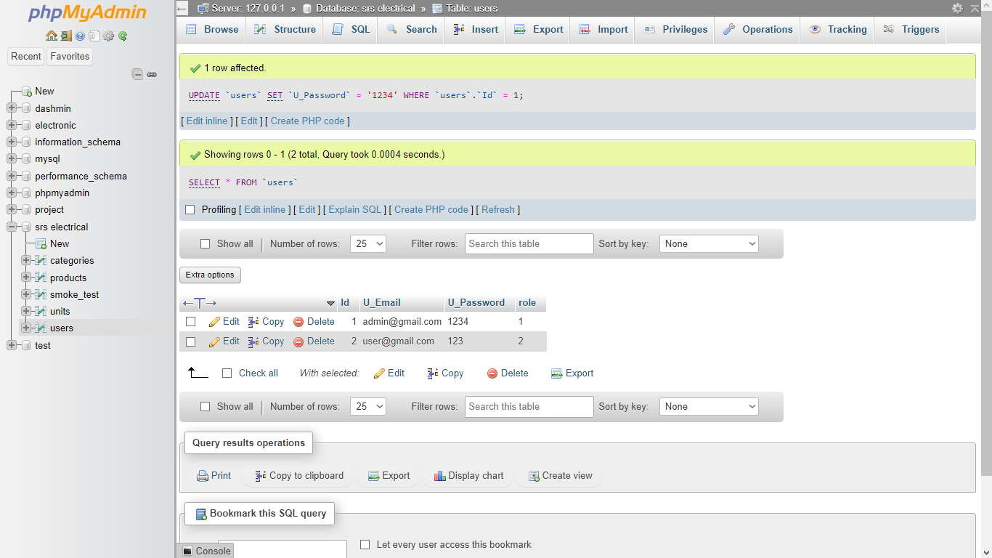

USERS

Source and screenshots:
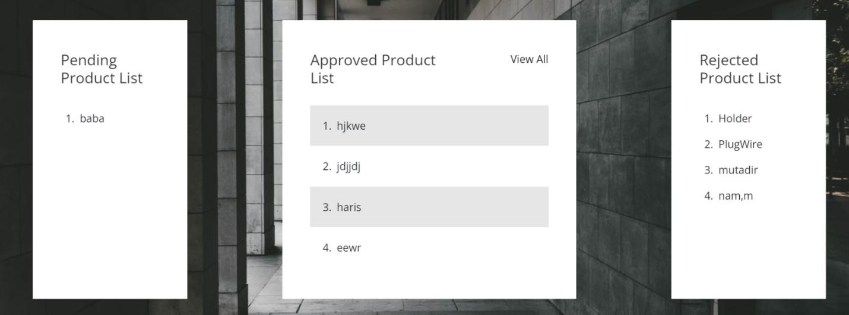
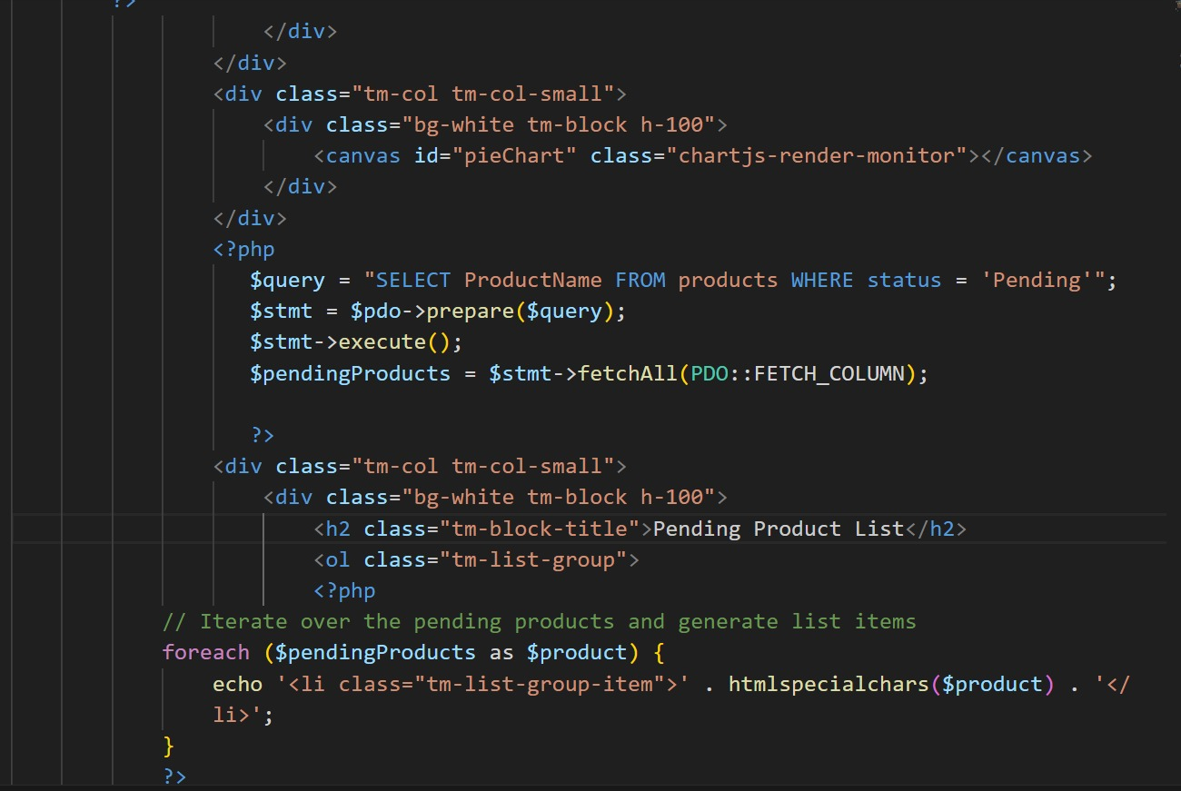
Index page
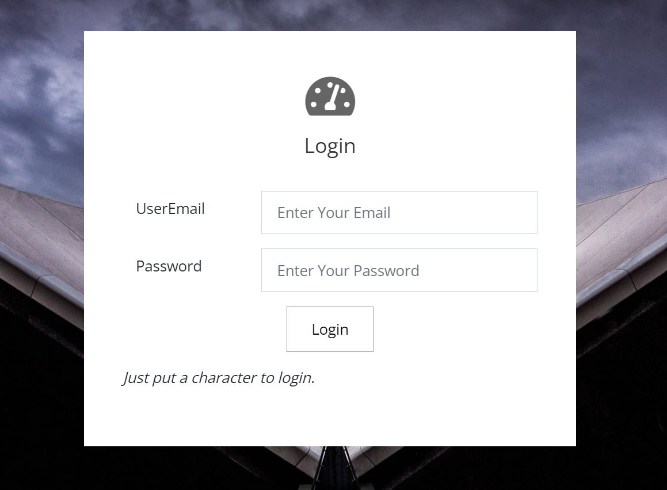
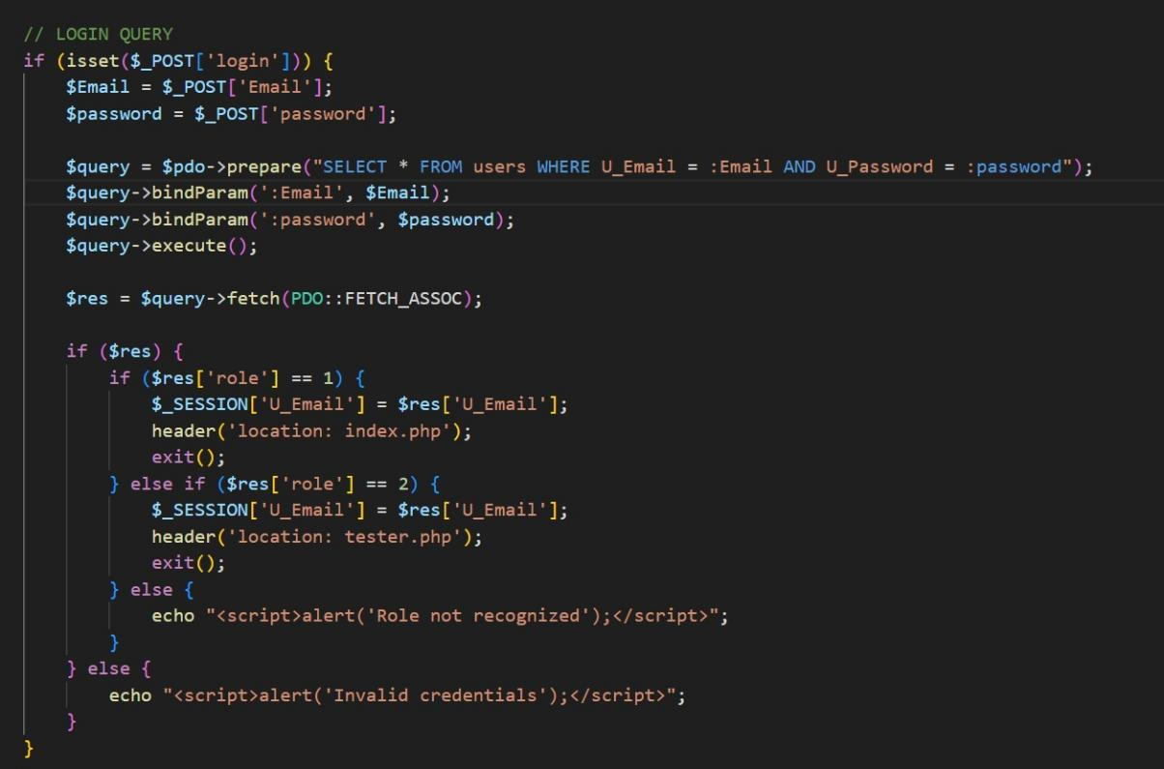
Login page
Add category page

Add product page
Update product

Update category

